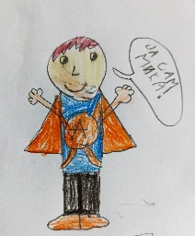
Jj

Jelena Angelovski: „Mika”

- Napiši uputstvo za pisanje jednog slova ćirilice.

__________________________________________________________________________________________________________________________________________________________________________________________________________________________________________________________________________________________________________________________________________________________________________________________________________________________________________________________________________________________________________________________________________________________________________________________________________________________________________________________________________________________________________________________________________________________________________________________________________________________________________________________________________________________

- Mikina supermoć je znanje ćirilice. Nacrtaj Miku kao superheroja u odgovarajućem kostimu.

