ЗАНИМАЊА

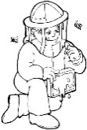1. Ко је приказан на слици:

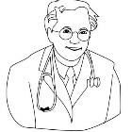

___________ _____________ _______________

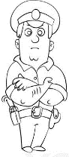

_____________ ______________ ____________

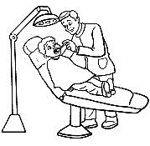

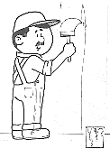

__________ ___________ ______________



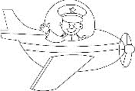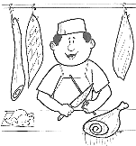

__________ __________ ___________

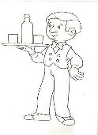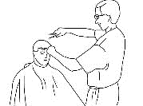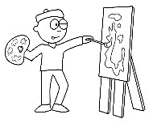

___________ ___________ _____________

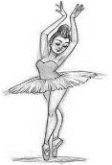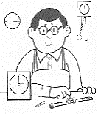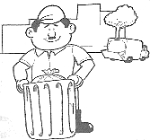

_____________ ___________ _______________

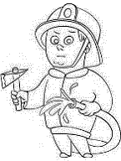

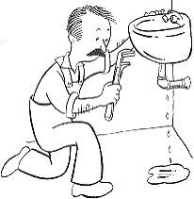

________________ ________________________

ЗАНИМАЊА

****1. Ко је приказан на слици:



___________ _____________ _______________



_____________ ______________ ____________





__________ ___________ ______________





__________ __________ ___________



___________ ___________ _____________



_____________ ___________ _______________





________________ ________________________