**ЗАНИМАЊА**

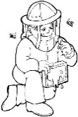1. Ко је приказан на слици:

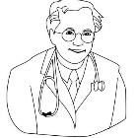

___________ _____________ _______________

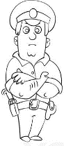

_____________ ______________ ____________

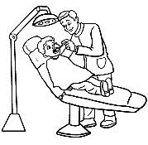

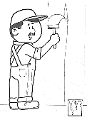

__________ ___________ ______________



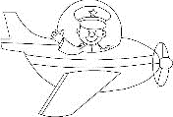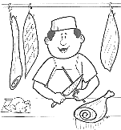

__________ __________ ___________

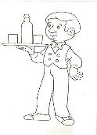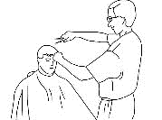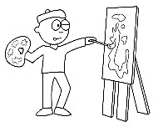

___________ ___________ _____________

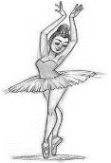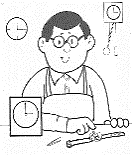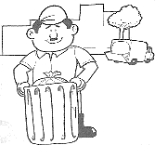

_____________ ___________ _______________

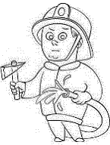

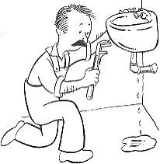

________________ ________________________

**ZANIMANJA**

****1. Ко је prikazan na slici:



___________ _____________ _______________



_____________ ______________ ____________





__________ ___________ ______________





__________ __________ ___________



___________ ___________ _____________



_____________ ___________ _______________





________________ ________________________