1. Opiši slike rečenicama:
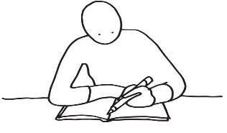
______________________________________

______________________________________

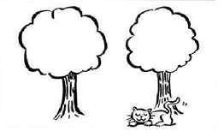

______________________________________

______________________________________

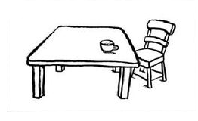
______________________________________

______________________________________

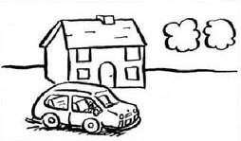

______________________________________

______________________________________

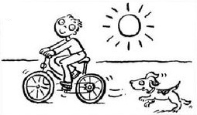
______________________________________

______________________________________

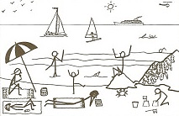
______________________________________

______________________________________

2. Nacrtaj sliku, a potom je opiši rečenicom:

______________________________________

______________________________________
1. Opiši slike rečenicama:
______________________________________

______________________________________

______________________________________

______________________________________

______________________________________

______________________________________

______________________________________

______________________________________

______________________________________

______________________________________

______________________________________

______________________________________

2. Nacrtaj sliku, a potom je opiši rečenicom:

______________________________________

______________________________________

