1. Napiši latinicom i ćirilicom nazive predmeta:
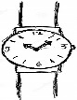
_____________ ________________
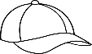
_____________ ________________
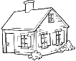
_____________ ________________
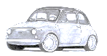
_____________ ________________
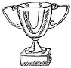
_____________ ________________
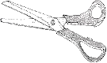
_____________ ________________
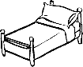
_____________ ________________
_____________ ________________
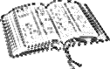
_____________ ________________
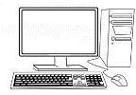
_____________ ________________

2. Napiši ćirilicom sledeća slova:

A ____, V ____, G ____, D ____, E ____,

Z ____, I ____, L ____, N ____, O ____,

R ____, S ____, U ____, F ____, H ____,

C ____, Ć ____, Č ____, Š ____, Đ ____,

Nj ____, Lj ____, Dž ____.

3. Napiši ćirilicom sledeće reči:

Srbi ____________, Srbija __________________
1. Napiši latinicom i ćirilicom nazive predmeta:
_____________ ________________
_____________ ________________
_____________ ________________
_____________ ________________
_____________ ________________
_____________ ________________
_____________ ________________
_____________ ________________
_____________ ________________
_____________ ________________

2. Napiši ćirilicom sledeća slova:

A ____, V ____, G ____, D ____, E ____,

Z ____, I ____, L ____, N ____, O ____,

R ____, S ____, U ____, F ____, H ____,

C ____, Ć ____, Č ____, Š ____, Đ ____,

Nj ____, Lj ____, Dž ____.

3. Napiši ćirilicom sledeće reči:

Srbi ____________, Srbija __________________
1. Napiši latinicom i ćirilicom nazive predmeta:
_____________ ________________
_____________ ________________
_____________ ________________
_____________ ________________
_____________ ________________
_____________ ________________
_____________ ________________
_____________ ________________
_____________ ________________
_____________ ________________

2. Napiši ćirilicom sledeća slova:

A ____, V ____, G ____, D ____, E ____,

Z ____, I ____, L ____, N ____, O ____,

R ____, S ____, U ____, F ____, H ____,

C ____, Ć ____, Č ____, Š ____, Đ ____,

Nj ____, Lj ____, Dž ____.

3. Napiši ćirilicom sledeće reči:

Srbi ____________, Srbija __________________

