Napiši ispod slike koji je sport prikazan i opiši šta sve vidiš na slikama:

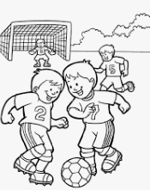 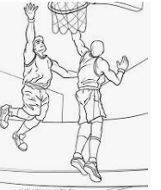 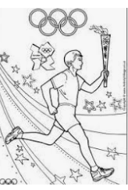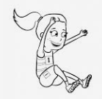______________________________________________________________________________________________

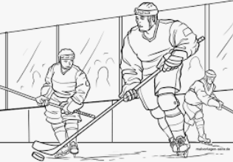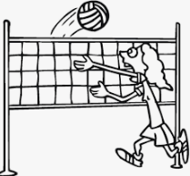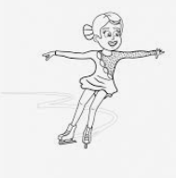

__________________________________________________________________________________________

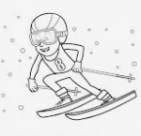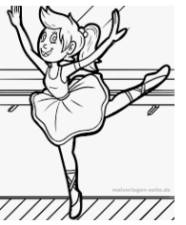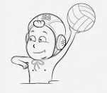

____________________________________________________________________________________________

1.Koji sport ti voliš?___________________________________________________

2. Oboj sličice.