1. Опиши слике:
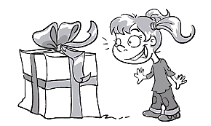

________________________________________
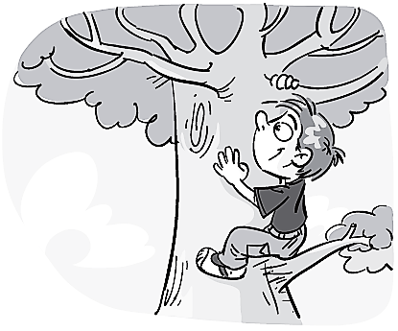

________________________________________
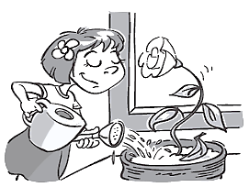

________________________________________
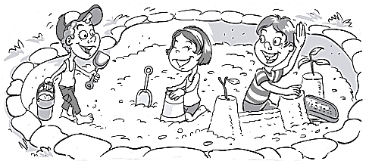

________________________________________
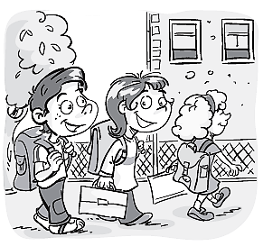

________________________________________
2. Опиши слике:
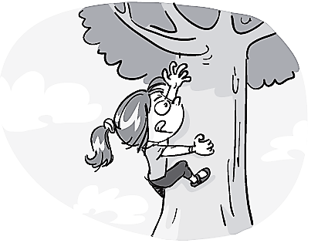

________________________________________
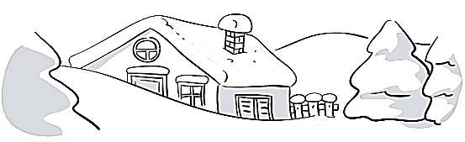

________________________________________
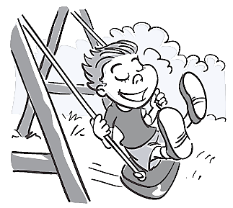

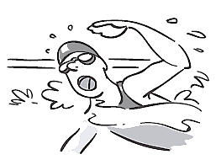
________________________________________

________________________________________
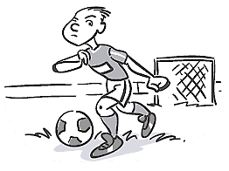

________________________________________
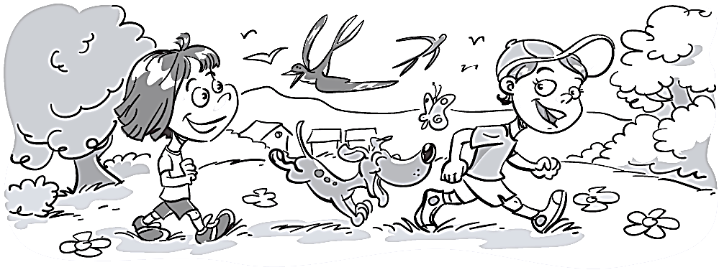
3. Напиши шта све видиш на сликама:

________________________________________

________________________________________

________________________________________

________________________________________
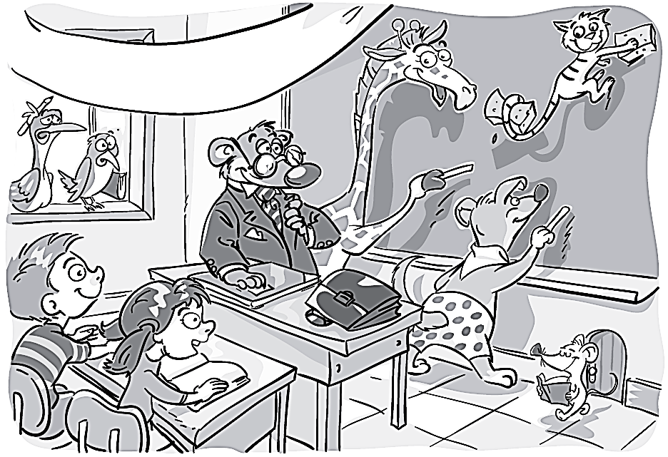

________________________________________

________________________________________

________________________________________

________________________________________
1. Opiši slike:

________________________________________

________________________________________

________________________________________

________________________________________

________________________________________
2. Opiši slike:

________________________________________

________________________________________

________________________________________

________________________________________

________________________________________
3. Napiši šta sve vidiš na slikama:

________________________________________

________________________________________

________________________________________

________________________________________

________________________________________

________________________________________

________________________________________

________________________________________

